How do Bees make Honey?
- Bees will fly many miles to find and collect nectar. Bees visit 100 flowers to fill up their stomachs, then fly back to their hive.
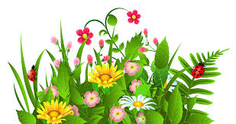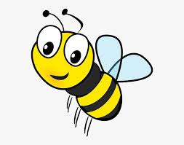
- Bees have two stomachs one for feeding and one for honey.
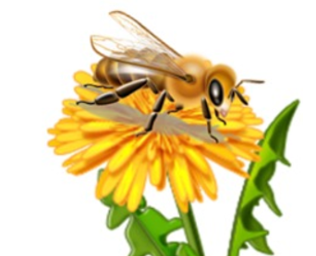
- Bees drink the nectar and store it in their honey stomach where enzymes start to break it down into simple sugars.
- Once their honey stomach is full, bees fly back to their hive and share the nectar with other bees to add more enzymes to it.
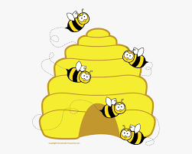
- The bee tells other bees where to find the nectar so they can go gather more!
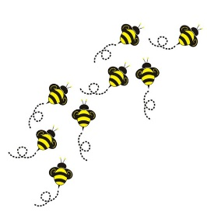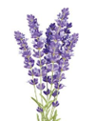
- After the nectar has been shared with the other bees and the enzymes have broken it down into sugars, the newly created runny honey is put into honeycomb to be stored.
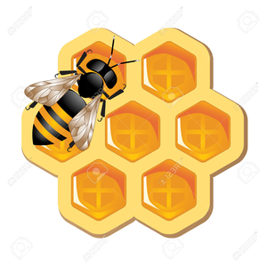
- Bees will then fan their wings to dry out the honey. When it is dry enough, they will seal it with wax so that it stays good.

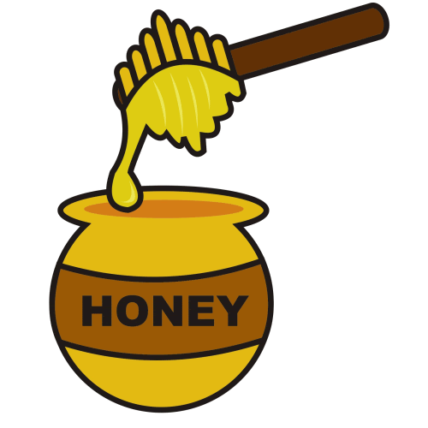Honey is very good for our health, it can be used to heal cuts

Make a Bee Bath
Do Bees need to drink water?
Yes, Bees need to drink water, so they keep hydrated just like us.

What will I need?
- Shallow container
- Stones
- Water

Choose a shallow dish

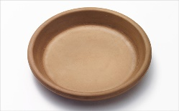

Collect some small stones

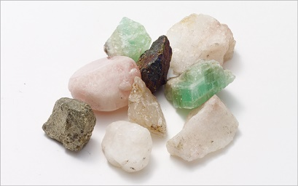

Put the stones into your dish. The Bees will stand on the stones and will be able to drink safely

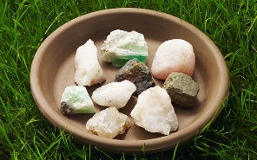
Fill the Bee bath up with water, don’t forget to top it up with water every day
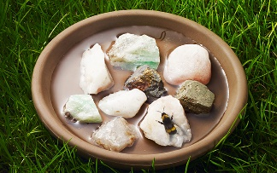
Make sure you find a nice sunny position that’s sheltered, somewhere you think the Bees would like to go for a drink

How do Bees use water to cool their hive?
Bees are very clever; they use water to cool down their Hive’s
The water collector bees fill their stomachs up with water and then fly back to the Hive. They regurgitate the water and other bees drink it up and spit the water out all over the hive to keep it cool.

These are just some of the fruit and vegetables bees
Pollinate, without bees these wouldn’t grow
Bee facts  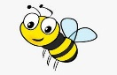  All worker bees are female | 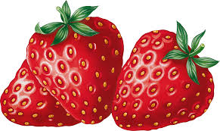  Strawberries |  | 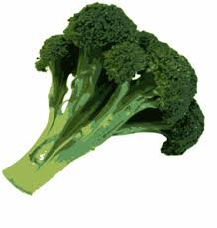  Broccoli | Bee facts  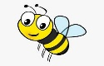  Honey is very good for you
 | Banana | Bee facts  A Bee produces about 5 grams of honey in her lifetime | 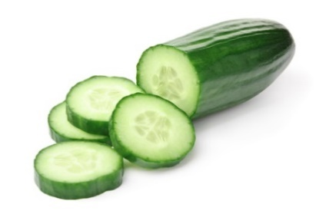  Cucumber
 | Tomato |  | 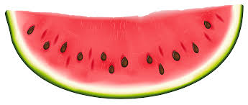  Melon
Bee facts  To get more Bees in your garden plant flowers with lots of colour | 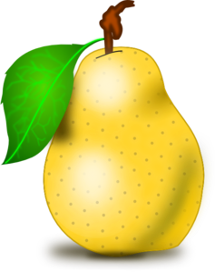  Pear |  | Apple | Bee facts  Bees love the colour blue they love Lavender

Next time you see a Bee in your garden, say a big thank you
to them for all they do for us
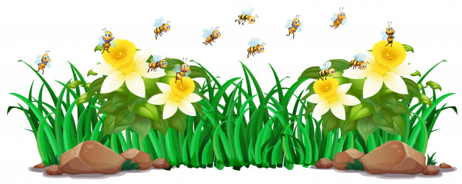
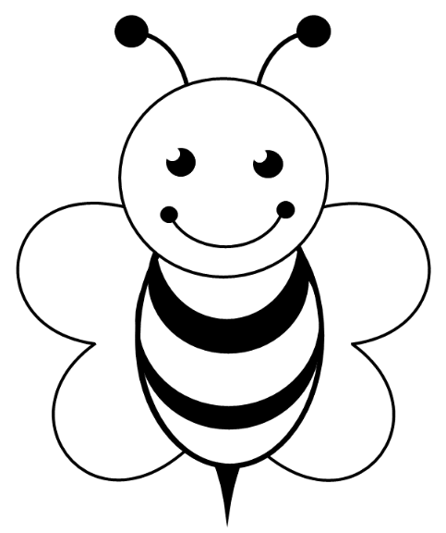

Colour your Bumble Bee

Can you help the bee to find the flowers?
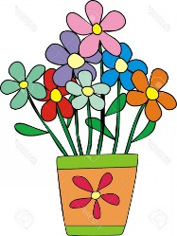

The Bee Quiz
How many stomachs do bees have? | - 4  - 1  - 2
How do you get bees to visit your garden? | - Put a welcome sign out  - Plant lots of colourful plants  - Don’t have any plants in your garden
What’s the bees favourite colour? | - Blue  - Brown  - Black
How many flowers do the bees need to visit to fill up their honey stomach? | - 20  - 100  - 500
All worker bees are female | True  False
Honey is very bad for you | True  False
Bees never drink water | True  False
Where do bees live? | - In a Hive  - In a bucket  - In a drain
In a bee’s lifetime, how much honey do they produce? | - 20 grams  - 100 grams  - 5 grams
How do bees keep the hive cool? | - Pour water all over it  - Plug a fan in  - Spit water all over the hive

Quiz answers – Bee Quiz
  - 2 stomachs
  - Plant lots of colourful plants
  - Blue
  - The bees visit 100 flowers
  - True
  - False
  - False
  - In a Hive
  - Bees produce 5 grams
10)Spit water all over the hive

How can we help the environment?
How many can you do in a week?
Re-use your water bottle
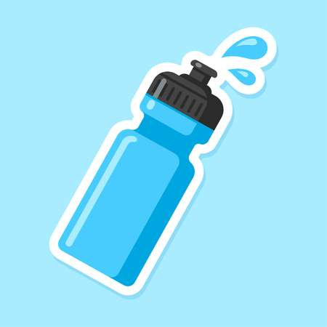
Save Water – when you brush your teeth or have a shower, make sure you only use the water you
need
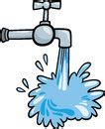
Collect rainwater and use it to water the plants in the garden
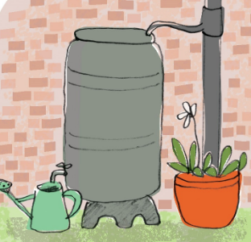
Save electricity, turn off the lights when you’re not in the room. Unplug your TV
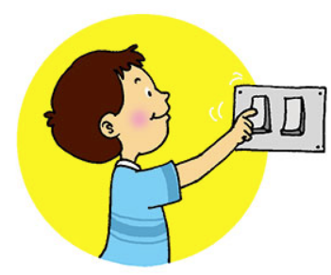

Have fun outside, riding your bike, going to the park, going for walks. Put away your games and turn the TV off for a while
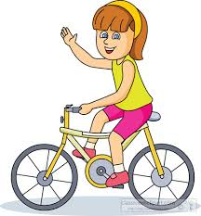

Start looking at what you can recycle – have a look at how you can reuse different things
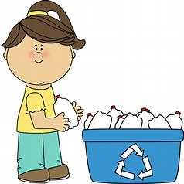

Have a go at growing your own vegetables in the garden. See how they grow and enjoy eating them
